# How to make a database diagram for the first time.

1- Open SSMS. Find ‘Database Diagrams’ in ‘Adventurework2014’ database.

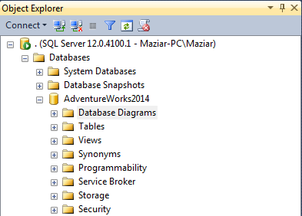

2- Click on ‘New Database Diagrams.

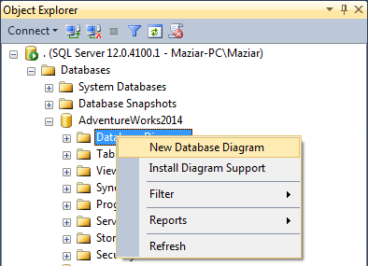

3- You might get this message. If you have already changed the owner of the database go to the step 7.

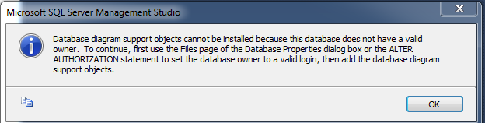

4- Right click on the name of your database and select ‘Properties’.

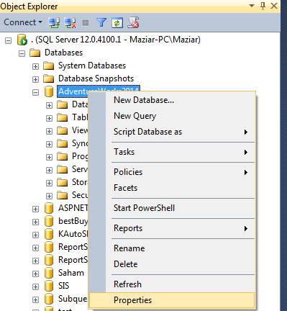

5- If the Owner Option is empty, click on the eclipse button.

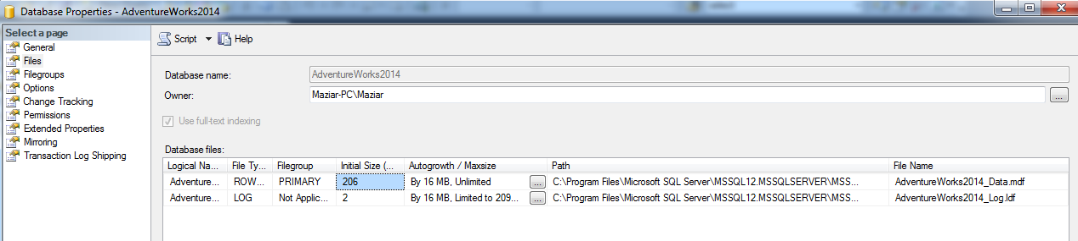

6- Click on ‘Browse’ button and check your name and then click ‘OK’

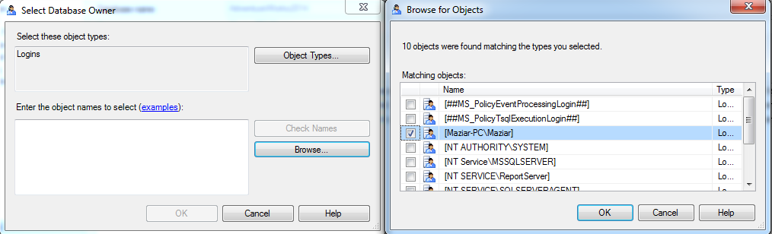

7- Now click on the ‘Database Diagrams’ again and click ‘yes’

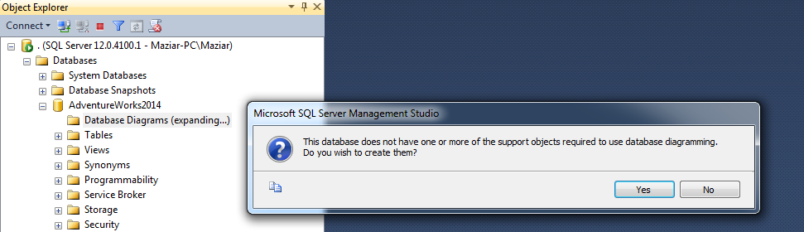

8- Right Click on the ‘Database Diagrams’ and select ‘New Database Diagram’

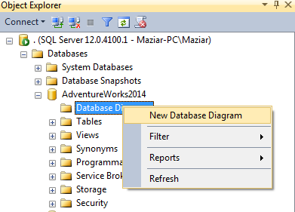

9- You can select your tables or you can close the window and drag and drop your tables to the diagram screen. Select the four tables you see below. 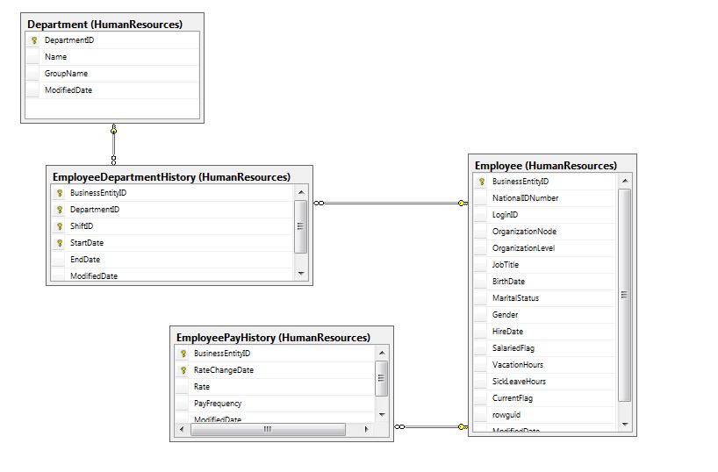

10- Save your diagram. The name of your first diagram is: ‘Department Diagram 1’

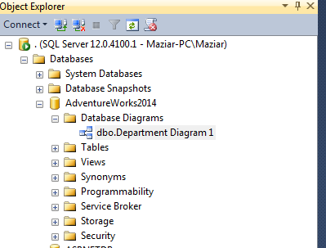

Congratulations. You made your first diagram.

Maziar